**DAILY ONLINE ACTIVITIES SUMMARY**

|  |  |  |  |  |  |  |  |  |
| --- | --- | --- | --- | --- | --- | --- | --- | --- |
| **Date:** | **13-6-2020** | | | | | **Name:** | **Pavana P** | |
| **Sem & Sec** | **6A** | | | | | **USN:** | **4AL17CS057** | |
| **Online Test Summary** | | | | | | | | |
| **Subject** | | **Python** | | | | | | |
| **Max. Marks** | | **30** | | **Score** | | | **30** | |
| **Certification Course Summary** | | | | | | | | |
| **Course** | **Python for data science.** | | | | | | | |
| **Certificate Provider** | | | Cognitive classes | | **Duration** | | | 7 hours |
| **Coding Challenges** | | | | | | | | |
| **Problem Statement:**  1.Write a C Program to calculate Electricity Bill  2. How to find the first non repeated character of a given String?  4.Python Program to print the pattern  3. Write a Java Program to determine whether a given matrix is a sparse matrix | | | | | | | | |
| **Status: Completed** | | | | | | | | |
| **Uploaded the report in Github** | | | | | **YES** | | | |
| **If yes Repository name** | | | | | **DAILY STATUS** | | | |
| **Uploaded the report in slack** | | | | | **YES** | | | |

.

**Online Test :**

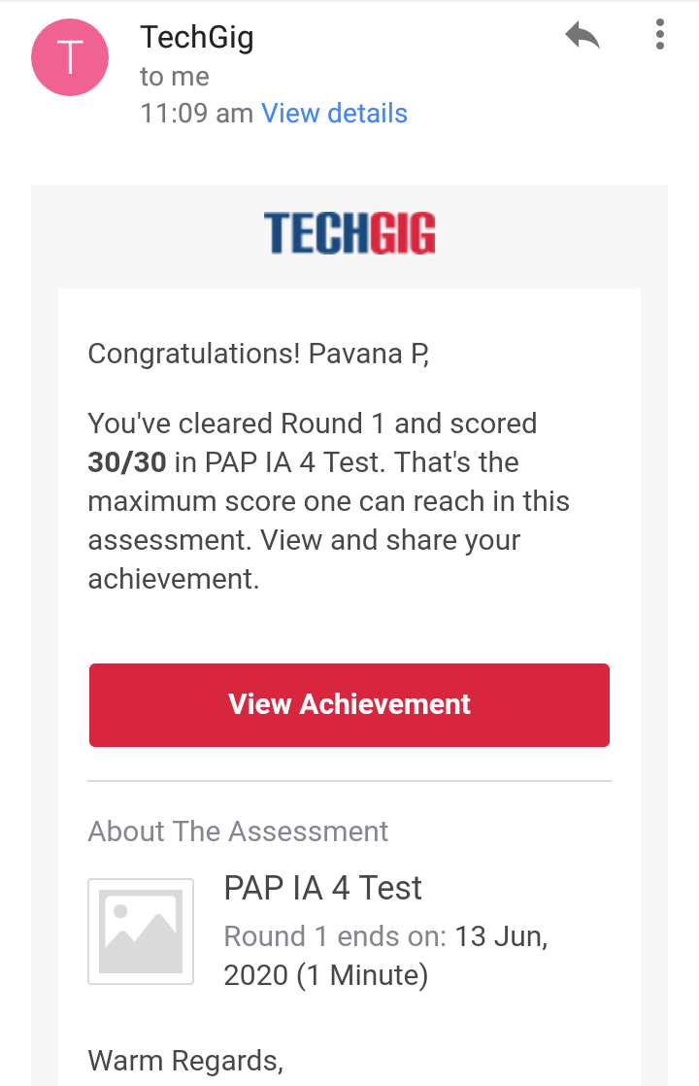Subject:-Python  
**Certification Course Details:**

**Python for data science:**

Today I have completed these topics:

1.Working with Data in Python.

2.Working with Saving data with Pandas.

3.Loading Data with Pandas.

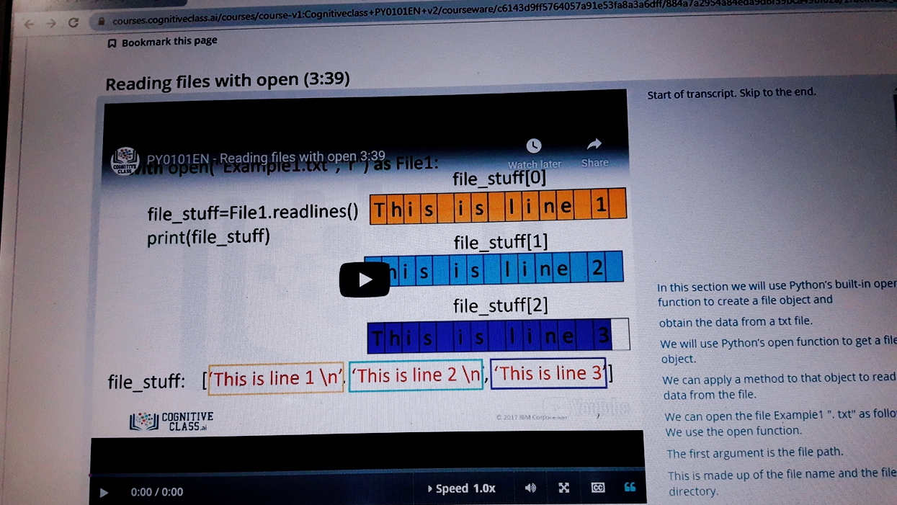

.

**Coding Challenges Details:**

**https://github.com/pavana-p-kulal/DAILY-STATUS/tree/master/13-6-20/Online%20Coding**